Experiment No: 8
Design and train a Convolutional Neural Network (CNN) on image datasets (e.g., MNIST/CIFAR)

1. Dataset Source
MNIST Dataset
Source: Built-in dataset in TensorFlow/Keras

2. Dataset Description
The MNIST dataset contains grayscale images of handwritten digits (0–9).
- Number of Instances: 70,000 images
- Image Size: 28 × 28 pixels

🔹 Features:
- Pixel values (0–255)

🔹 Target Variable:
- Digit label (0–9)

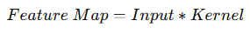
3. Mathematical Formulation

🔹 Convolution Operation:

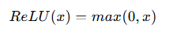
🔹 Activation Function:

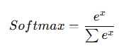

🔹 Output Layer:

4. Algorithm Limitations
- Requires high computation
- Needs large data
- Training time is high
- Requires GPU for speed

5. Methodology / Workflow
- Load MNIST dataset
- Normalize pixel values
- Reshape data for CNN
- Build CNN model
- Train model
- Evaluate accuracy
- Visualize results

6. Performance Analysis
- Evaluate using accuracy
- CNN captures spatial features
- Gives high accuracy for image classification

7. Hyperparameter Tuning
- Number of filters
- Kernel size
- Epochs
- Batch size
Code:
# ================= STEP 1: IMPORT =================
import numpy as np
import matplotlib.pyplot as plt
from tensorflow import keras
from tensorflow.keras import layers

# ================= STEP 2: LOAD DATA =================
(x_train, y_train), (x_test, y_test) = keras.datasets.mnist.load_data()

print("Train shape:", x_train.shape)

# ================= STEP 3: NORMALIZATION =================
x_train = x_train / 255.0
x_test = x_test / 255.0

# ================= STEP 4: RESHAPE =================
x_train = x_train.reshape(-1, 28, 28, 1)
x_test = x_test.reshape(-1, 28, 28, 1)

# ================= STEP 5: BUILD CNN =================
model = keras.Sequential([
layers.Conv2D(32, (3,3), activation='relu', input_shape=(28,28,1)),
layers.MaxPooling2D((2,2)),

layers.Conv2D(64, (3,3), activation='relu'),
layers.MaxPooling2D((2,2)),

layers.Flatten(),
layers.Dense(64, activation='relu'),
layers.Dense(10, activation='softmax')
])

# ================= STEP 6: COMPILE =================
model.compile(
optimizer='adam',
loss='sparse_categorical_crossentropy',
metrics=['accuracy']
)

# ================= STEP 7: TRAIN =================
history = model.fit(
x_train, y_train,
epochs=5,
batch_size=32,
validation_split=0.2
)

# ================= STEP 8: EVALUATE =================
loss, acc = model.evaluate(x_test, y_test)
print("Test Accuracy:", acc)

# ================= STEP 9: VISUALIZE =================
plt.plot(history.history['accuracy'], label='train')
plt.plot(history.history['val_accuracy'], label='val')
plt.title("Model Accuracy")
plt.xlabel("Epoch")
plt.ylabel("Accuracy")
plt.legend()
plt.show()

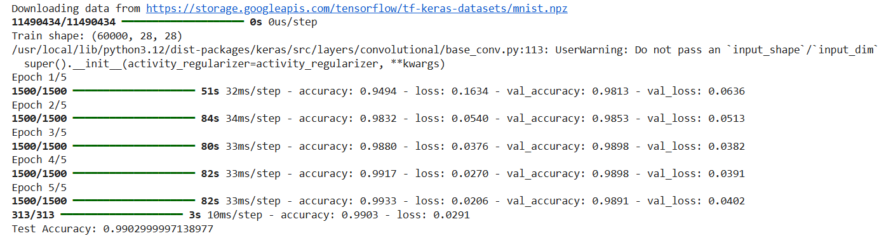
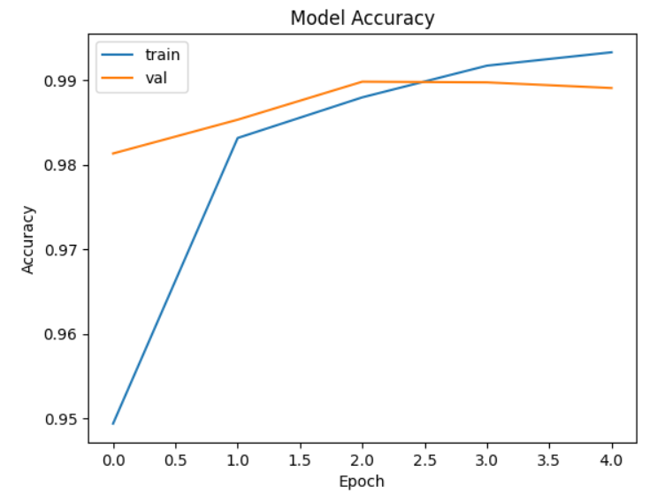

Conclusion:
A Convolutional Neural Network was successfully implemented on the MNIST dataset. The model achieved high accuracy by effectively learning spatial features from images, demonstrating the power of CNNs in image classification tasks.

